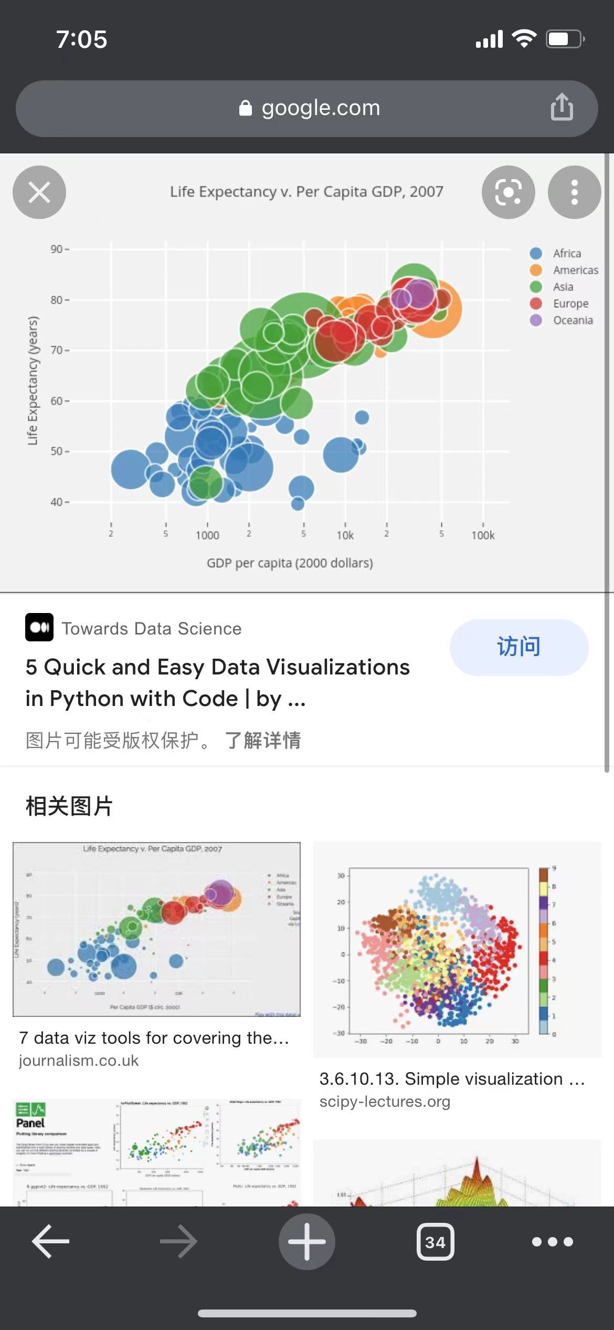

This is a relationship between the life expectancy and the corresponding GDP of (each country?). This graph has no illustration of what each circle stands for so we don’t know if it is a country or a local area. However, the good parts of this is it separates the continents with color so it can visualize the difference between countinets.